Project Name: Smart Home
Team members: Zhang Honghao, Ren Tianyang, Jiang Lei, and Lan Kun

1. Abstract
This project addresses pain points such as "fragmented multi-brand protocols, invisible energy consumption, fragmented security alerts, and offline inavailability," proposing a low-cost, easy-to-install smart home prototype with a unified browser-based 3D digital twin interface. By integrating Next.js/React/TypeScript + Three.js + ECharts, it achieves a unified visualization of home spaces and device statuses. Combined with IndexedDB's local priority and device state machines, it ensures strong consistency in UI/data/scenarios and offline availability, supporting the mapping of ≥5 types of devices including lighting, doors/windows, air conditioners, TVs, and cameras, as well as "one-click scenario" (leaving/homcoming/sleeping) interactions. The system reserves REST/MQTT/WebSocket interfaces for seamless integration with real gateways/clouds, employs DRACO/LOD/visual cone clipping to ensure performance, and implements a security baseline with strong passwords, minimal permissions, and local encryption. Following the predefined Gantt chart from October 27 to November 26, the project completed an end-to-end closed loop from requirements and selection to implementation and joint debugging, with target metrics including scenario switching response ≤3s, status consistency ≥99%, and a reduction of ≥20% in idle standby/invalid operation time in the experimental environment. The prototype also serves educational and demonstration purposes while laying the foundation for future industrial expansion, paving the way for subsequent integration with Matter/Thread and energy efficiency evaluation.

II. Project Background and Introduction

2.1 Project Background and Problem Statement
The project chose smart homes because the rapid digitization of living scenarios is still fragmented: multiple brands and protocols lead to scattered operations and high learning costs, invisible energy consumption causes idle standby and idling, fragmented security alerts lack coordination, states often differ, and offline access is unavailable, with insufficient accessibility for elderly and visually impaired users, and a lack of quantifiable input-output metrics. The root cause lies in the absence of a unified device capability abstraction and local consistency layer, the lack of a "spatial mapping" digital twin interface, and weak security baselines. To address this, the project uses browser-side digital twins as a "single truth interface," visualizes device locations and statuses with Three.js+Next.js, establishes IndexedDB for local persistence and device state machines to ensure strong consistency between UI/data/scenarios and support offline access; presents temperature, air quality, and water/electricity indicators with ECharts and supports "one-click scenario" coordination; while reserving REST/MQTT/WebSocket interfaces to connect to real gateways/clouds, implementing strong passwords, minimal permissions, and local encryption security baselines. The goal is to reduce idle energy consumption, compress response times to ≤3 seconds, improve accessibility and usability, support ≥5 types of devices and reduce adaptation costs, and support ROI evaluation of energy efficiency and savings through visual metrics.

2.2 Project Objectives and Scope
The objective of this project is to build a low-cost, easy-to-install, browser-based smart home control prototype without relying on dedicated gateways or expensive modifications. Using digital twins as a unified interface, it addresses issues such as multi-brand decentralized control, invisible energy consumption, fragmented security alerts, and asynchronous status. Through Three.js+Next.js, it integrates the presentation of home spaces and device statuses. Based on IndexedDB's local priority and device state machine, it achieves offline availability and strong consistency. Combined with ECharts, it provides metrics like temperature, air quality, water, and electricity, along with "one-click scenarios" (leaving, returning, bedtime). It reserves REST/MQTT/WebSocket interfaces for connecting to real gateways or the cloud. Measurable phased goals include: completing the mapping and control of ≥5 categories of devices such as lights, doors/windows, air conditioners, TVs, and cameras; ensuring common operations and scenario switching response times ≤3s; achieving UI/data/scenario status consistency ≥99%; reducing idle/invalid operation time by ≥20% in experimental environments; supporting bilingual Chinese/English and basic accessibility (keyboard accessibility, compliance with contrast); being ready for single-machine deployment with low learning costs; covering login/registration and session management, 3D scene loading and roaming, device control and tag display, dashboard charts and monitoring windows, local persistence and consistency verification, basic security baselines (strong passwords, minimum permissions, local encryption of sensitive information), and project documentation and demonstrations. The scope currently excludes vendor-specific deep drivers and hardware modifications, cloud multi-tenant operations and message orchestration, voice assistant and complex AI power consumption prediction, security authentication and compliance auditing, etc. (interfaces are reserved for future iteration integration).

2.3 Explanation of the report structure
This report focuses on the goal of "achieving a prototype of smart home with a unified interface based on browser-side 3D digital twins, prioritizing local access and strong consistency." Chapter 1 serves as the abstract, summarizing the project motivation, core technical roadmap, and interim achievements (including Next.js/React/TS + Three.js + ECharts + IndexedDB, etc.). Chapter 2 introduces the project background and introduction: 2.1 presents the problem statement and pain points, 2.2 clarifies the project objectives, scope, and boundaries (including offline availability, device mapping, metric visualization, and reserved interfaces). Chapter 3 argues for feasibility from four perspectives: market, technology, finance, and operational management, explaining the project implementation scenarios and differentiated value. Chapter 4 delves into the solution and design, detailing the overall architecture, functional module designs, user interface and interaction design, complete feature list, and operation manual, forming a closed loop of "requirements—design—implementation—validation." Chapter 5 outlines team division of labor, task breakdown, timeline, and communication mechanisms. Chapter 6 evaluates technical, market, and management risks, proposing corresponding strategies. Chapter 7 provides conclusions and future prospects, summarizing the project achievements and shortcomings, and suggesting directions for expansion in the next phase. Finally, Chapter 8 compiles references and appendices, providing traceable evidence for implementation details and future research.

III. Market and Feasibility Analysis

3.1 Market Feasibility Analysis
From the perspective of market size and trends, smart homes are upgrading from "single-item intelligence" to "platform-based linkage + energy efficiency and performance improvement." Short-term growth is driven by lighting, security, and comfort devices (lights, doors/windows/locks, cameras, air conditioners/thermostats), while long-term growth is propelled by the combined forces of "local priority and privacy," "energy-saving regulation and refined electricity pricing," "standardized interconnection like Matter," "aging population and caregiving needs," and "lightweight AI on the edge." Our target users fall into three main categories: ① Urban youth and tech-savvy families who rent or own their first home, seeking low-cost, easy-to-deploy solutions with smartphone/browser accessibility and one-click scenarios; ② Ordinary families and small property owners with energy-saving and security needs, emphasizing energy consumption visualization, remote monitoring, linkage strategies, and offline availability; ③ Elderly and family caregiving scenarios, preferring simple-to-use interfaces, reliable alerts, and minimal hassle. In terms of competitive landscape, the strengths of Apple Home/Google Home/Amazon Alexa ecosystems lie in extensive device coverage, mature voice entry points, and strong stability, while their weaknesses include deep ecosystem binding, high costs and privacy concerns, limited 3D spatial visualization, and weak local consistency. Platforms like Xiaomi/Huawei/Tuya have advantages in diverse hardware, affordable pricing, and comprehensive product lines, but face challenges in cross-brand interoperability, overseas localization, fragmented protocols, and uncertainties regarding data sovereignty and long-term maintenance. Professional security and traditional integrators excel in reliability and home service, but struggle with high retrofitting costs and difficult secondary development. Building on this foundation, the project adopts a browser-based digital twin solution with local persistence and plug-and-play backend, delivering a differentiated approach featuring "low cost, easy installation, cross-platform display, offline functionality, and measurable energy efficiency." It focuses on high-frequency essential needs (lights, doors/windows, air conditioners, TVs, cameras) and one-click scenarios, aligning with industry trends of standardization and energy-saving data-driven solutions. The project demonstrates feasibility and scalability across market segments, from student and entry-level households to small-scale property management.

3.2 Technical Feasibility Analysis
In terms of technical feasibility, the core approach of this project is "browser-based digital twin + local priority": the front-end uses Next.js/React/TypeScript + Three.js + ECharts to build a 3D visual and instrument panel, with devices and historical data stored in IndexedDB (offline available). Through an abstract "device capability model" (on/off, brightness/color, mode, location, etc.), it unifies different brands and protocols; physical access is divided into two layers: 1) Directly connected smart sockets, lights, cameras, etc., via Wi-Fi/HTTP/WebSocket; 2) Optional edge gateways (Raspberry Pi or industrial computers) that aggregate Zigbee/BLE devices and bridge to MQTT (Mosquitto/EMQX), with potential smooth evolution to Matter/Thread; communication uses a unified JSON topic schema (e.g., home/{room}/{device}, with separate topics for attribute reporting and command issuance), employing an optimistic update + periodic reconciliation state machine to ensure strong consistency between UI/data/device and handle offline compensation; key challenges and solutions: protocol fragmentation → encapsulated drivers using capability models + adapter patterns; real-time and consistency → device shadows + version number/time reconciliation (idempotent commands, retry backoff); 3D performance → lightweight models/DRACO compression, LOD/conical clipping, on-demand rendering; Video playback → Local short-latency sources (MP4/HLS) take priority; if failed, it degrades to thumbnail polling; Security and privacy → Strong passwords and minimal permissions, token authentication (JWT) and TLS, local encryption of sensitive fields, key operation audit logs; Data volume and visualization performance → Time-series data bucketing and sampling drill-down, ECharts windowed loading; Device discovery and naming → Gateway unified discovery and naming according to the "space-device-capability" standard; Tool and resource requirements: Node.js 20+, pnpm, Chrome, MQTT Broker (Mosquitto/EMQX), MQTT Explorer/Postman, Wireshark (packet capture and localization), ESP32/ESPHome or Zigbee2MQTT suite (door sensors/human sensors/PIR, temperature and humidity, PM2.5/TVOC, water immersion, power socket), Raspberry Pi 4 (optional gateway), Vitest/Playwright (testing), ESlint/Prettier/Lighthouse (quality and performance), with a minimum available closed loop (lightsDoors, windows, air conditioners, televisions, cameras ≥5 categories of devices) to verify end-to-end feasibility and leave room for future integration with cloud REST/MQTT/WebSocket.

3.3 Financial Feasibility Analysis
The financial feasibility of this project is generally controllable: In terms of cost estimation, the hardware is configured according to the "minimum available closed loop (≥5 types of devices)," including Raspberry Pi 4 (optional gateway, approximately CAD 90-120), Zigbee coordinator or several ESP32/ESPHome (each CAD 10-25), temperature and humidity/door magnet/PIR/water immersion/PM2.5 sensors (each CAD 10-30), smart sockets and lights with metering (each CAD 20-35), entry-level cameras (CAD 30-60), totaling approximately CAD 300-600; the software primarily uses open-source solutions like Next.js/Three.js/ECharts/Mosquitto (software license costs ≈ 0), and tools used for development and testing such as Node.js, pnpm, Playwright/Vitest, MQTT Explorer, and Wireshark are all free; operational costs mainly involve local running, with cloud services being activated on demand at the lowest VPS (CAD 5-10/month) and domain (CAD 15/year), while the marginal costs of electricity and bandwidth are negligible; human resource input is estimated at a Gantt chart total of ≥120 hours (per capita ≥25 hours), which are required for course learning and practical sessions and are not converted into cash expenses. The funding requirements and sources can adopt a combination of self-funding, small-scale campus funds/curriculum project funds, and competition/innovation fund applications. It is recommended to allocate prototype hardware with a maximum budget of CAD 600 in the initial phase, with subsequent incremental purchases based on demonstration and acceptance results. Potential benefits/values are mainly reflected in: 1) Energy efficiency – visualizing and strategically linking idle standby and ineffective operations, aiming to reduce relevant duration by ≥20%, which translates to measurable savings based on household annual electricity costs; 2) Efficiency improvement – one-click scenarios (leaving/homcoming/sleeping) consolidate multi-step operations into ≤3 steps, reducing misoperations and learning costs; 3) Safety and reliability – prioritizing local operations and state consistency to reduce cloud dependency and latency, enhancing critical control availability; 4) Scalability and educational/research value – standardized device capability models and interfaces like MQTT/Matter facilitate future integration with real devices and academic/competitive extensions; 5) Brand and demonstration value – creating demonstrable project assets through browser-based digital twins, aiding course evaluations, roadshows, and subsequent industrial exploration. Overall, the prototype phase achieves clear, quantifiable energy-saving and efficiency gains with low hardware investment, zero licensing fees, and controllable maintenance costs, offering financial advantages of low threshold, low risk, and scalability.

3.4 Feasibility Analysis of Operation and Management
Upon completion, the project will implement a "light operations, versioned, and sustainable" management strategy. Version control will be managed through SemVer with monthly patches and quarterly minor updates (security patches applied immediately), while requirements/defects will be prioritized (P0-P3) and tracked via GitHub Issues + Projects. The system will incorporate CI/CD pipelines (linting, unit testing, and end-to-end regression) with pre-release performance baseline verification. Operations will prioritize on-premises infrastructure to minimize cloud dependencies, enabling only minimal MQTT/REST services for remote access. Blue-green deployment and one-click rollback scripts will be provided, along with configuration snapshot backups (including device mapping and policy templates). Monitoring and observability will utilize browser-based log aggregation, error reporting, and simple status heartbeats, with key metrics including status consistency (≥99%), scenario transition response (≤3s), and failure rate (≤0.1%). Security operations will enforce weekly vulnerability audits (npm audit/CVE subscriptions), strong passwords with minimal privileges, token rotation, and local encryption of sensitive fields. Documentation and knowledge retention will include operation manuals, adapter specifications (device capability models), API contracts, common troubleshooting guides, along with change logs and migration roadmaps. The team maintains continuous operational capabilities: Zhang Honghao oversees 3D twin technology, control orchestration, and technical documentation; Jiang Lei manages framework integration and release pipelines; Ren Tianyang ensures data consistency and metric standards; while Lan Kun handles control panels and accessibility. The team collaborates to establish Code Owners and conduct cross-team reviews, with a testing coverage rate of ≥70% and a duty calendar (lightweight SLA: P1 resolution within 24 hours, P2 within 48 hours). A roadmap is reserved for v1.1 stability fixes, v1.2 device compatibility extensions, and v1.3 backend/gateway integration, ensuring sustainable system evolution and cost-effective operations.

IV. Project Plan and Design

4.1 Overall System Architecture Design
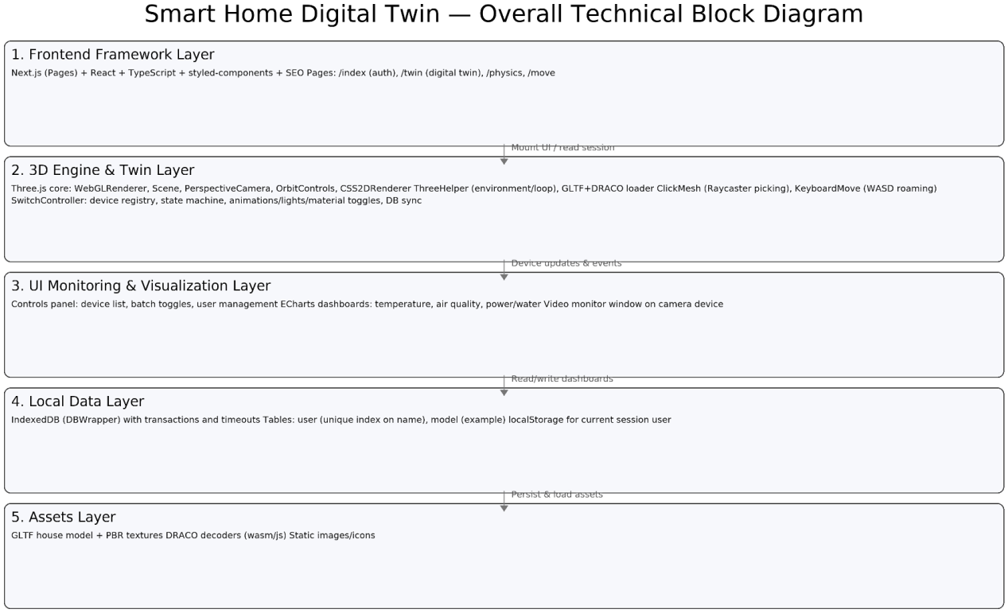
Figure 4.1 Project Technical Block Diagram

architecture layering
1) Presentation layer
Next.js Pages: Routing and first screen (login/registration, Twin, Physics, Move).
React components: Canvas (WebGL canvas), ControlsPlane (control panel), ECharts (charts), video monitoring window, user cards, etc.
Style System: styled-components theme with global styles (/src/styled/**), NextSEO SEO component.

2) Twin Engine Layer
ThreeHelper provides unified initialization for Renderer, Scene, Camera, Controls, and LabelRenderer, along with convenient methods for lighting, sky, and environment.
Model loading: GLTF + DRACO decoding, loading building structures and equipment nodes.
Interactive Sampling: ClickMesh responds to click/dblclick via Raycaster, while KeyboardMove handles WASD navigation.
Device orchestration: The SwitchController scans registered devices (e.g., doors, windows, lights, TVs, air conditioners, cameras) and configures on/off behaviors for each category.
Animation (door/window/air conditioner unit): forward/reverse push through AnimationMixer.setTime (t);
Material/Color category (e.g., TVs): Switch MeshStandardMaterial color or properties.
Light source type (lights/fixes): Adjust light intensity and visibility.
Monitoring category (camera): triggers the UI monitoring panel to display.
Tag: Add CSS2DObject tags to each device to show or hide as needed.
Frame loop: Calls switchController.update() in helper.animation() for each frame, advancing only for devices in running status.

3) Data & Persistence Layer
DBWrapper (IndexedDB wrapper): Abstracts transactional operations and index queries, providing get, add, put, getAll, and getAllMatching methods.
State synchronization: asyncDevice() periodically verifies the consistency between the "visible state (scenario)" and the "data state (IndexedDB.user)":
If the state and DB's off are inconsistent, automatically toggle() to correct.
After switching, call updateDB(name) to write the device status (including usage time and status), and synchronize the control panel device list.
Session information: localStorage("user") stores the current logged-in user for all pages to access.

4) Resource Layer (Assets)
GLTF/DRACO/textures: /public/models/HOUSE/** (with PBR textures), /public/draco/** (wasm/js decoder).
Media: /public/video/JianKong.mov for monitoring window.

End-to-end workflow (using the "Twin Page" example)
1) User login (/pages/index.tsx):
Enter username/password → IndexedDB queries user → Log in if found; otherwise register and log in.
Write the user object to localStorage.
2) Load the twin scene (/pages/twin.tsx):
Canvas initializes ThreeHelper to create the camera, lighting, and tag renderers for rendering.
Load house.gltf, SwitchController scans the scene to register devices and establishes the devices table.
The control panel (ControlsPlane) retrieves devices and renders the device list.
3) Status consistency check:
asyncDevice() retrieves the current user device status from IndexedDB and compares it with the device status in the scenario. If inconsistent, toggle() automatically corrects the discrepancy to ensure consistency in UI, data, and 3D.
4) User interaction:
Click device: Show/Hide CSS2D tag
Double-click the device: triggers the device switch (animation/light/material/video panel);
Panel operations: Batch switch or display device status, open monitoring/user management.
Keyboard WASD: Roaming Space.
5) Continuous updates:
Advance the running device animation or material/light source changes in the frame loop.
When switching, write back IndexedDB and refresh the panel and tabs.

4.2 Detailed Design of Functional Modules
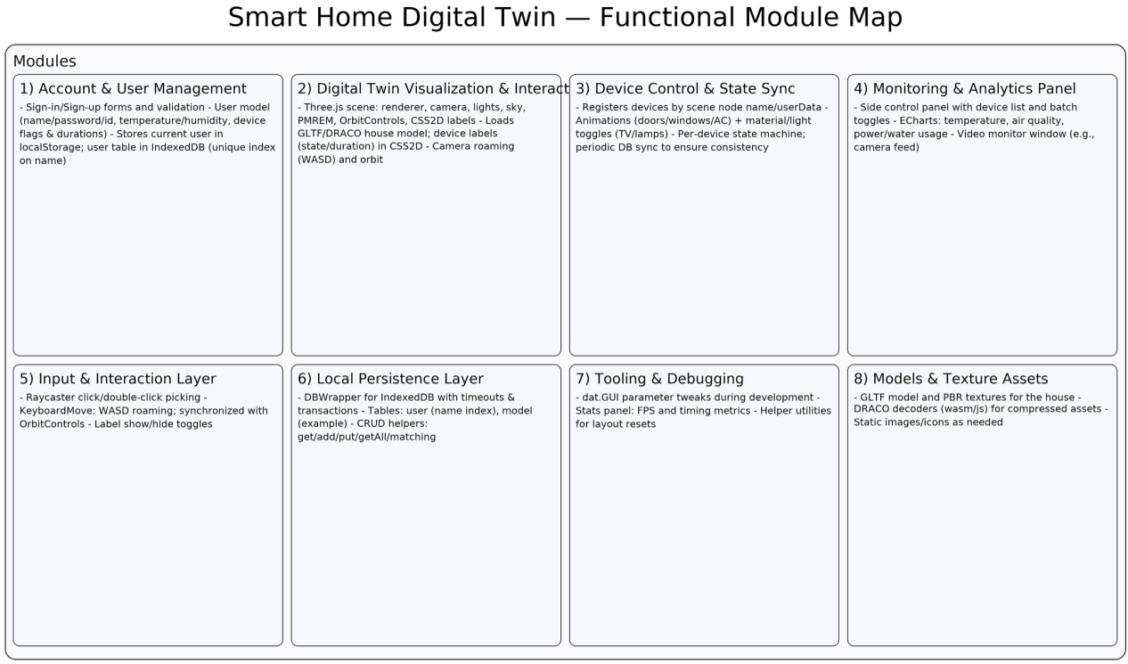
Figure 4.2 Project Function Module Diagram

Account and User Management (/pages/index.tsx,/src/pages/twin/Account.tsx)
Login/Registration form: The page includes login and registration options. The system verifies password consistency twice during registration.
User data model: DBUserInfo contains name/password/id/temperature/humidity, duration for each device, and off field; devicesName includes predefined options such as "Air Conditioner/Main Bedroom/Living Room TV/Door/Light/Balcony Left/Right Door/Fan/Candelabrum".
Storage: The encapsulated DBWrapper writes to IndexedDB's user table (with unique index names). After login, the user object is stored in localStorage("user") for other pages to access.
② Digital twin visualization and interaction (/pages/twin.tsx,/src/components/Three/Canvas.tsx, /src/ThreeHelper/**)
3D scene setup: ThreeHelper (BaseEnvironment) integrates WebGL Renderer, Scene, Perspective Camera, Orbit Controls, and CSS2D Renderer, with unified packaging for lighting, sky, PMREM, layout reset, and frame loop functions.
Model loading: Load the house model from /public/models/HOUSE/house.gltf (support DRACO decompression, see /public/draco/** and /src/ThreeHelper/draco/**).
Labels and information: CSS2DObject adds 2D labels (work duration/status notifications) to the device, which are centrally mounted in the #label container.
Roaming and Perspective: The built-in camera supports roaming and keyboard-based movement (e.g., KeyboardMove), with WASD keys for panning and OrbitControls for directional control.
3. Equipment control / status synchronization (/src/pages/twin/SwitchController.ts)
Device registration: Traverse GLTF scene nodes and create a device table devices: Record<uuid, {...}> by using node name/userData.
Supported types (example):
Door/Window: Enables AnimationMixer to play or rewind animations (on/off controls progression/rewind of setTime(t)).
Light/Bind point: If the node is a light or a userData.bind, switch the intensity/visibility of the real light object.
TV (Bedroom/Living Room): Switch MeshStandardMaterial color (Black Screen ↔ Original Color).
Air conditioner ("AC"): Bound to animation or status; also supports indirect control via the casing by clicking to bind.
Camera: Double-click "Camera" to display the monitoring panel (linked to the UI panel).
State Machine: Each device maintains a state ("on" | "off") or running/animation/mixer/action/target. During updates, it increments or decrements t per frame to drive animations or changes in materials, colors, and lighting.
Database synchronization: The asyncDevice() method periodically checks user device status in IndexedDB. When discrepancies are detected with the 3D device table, it automatically triggers toggle() to correct and write back the status, ensuring consistency between the 'visible state' and 'data state'.
④ Monitoring and Visualization Panel (/src/pages/twin/ControlsPlane/**)
Side control panel: Device list, batch display and toggle of status; one-click display/hide device labels (setDevices / toggleCss2DObject).
Chart (ECharts):
Temperature (Temperature.tsx), air quality (AirQuality.tsx), electricity/water (PowerConsumption.tsx/WaterConsumption.tsx).
It can connect to the "physical end" or backend data. The current demo uses dynamic/simulated data to display UI capabilities.
Surveillance video (Monitor.tsx): Click the "Camera" device to pop up the video window (/public/video/JianKong.mov).
User management (UserManage.tsx): Pull all users from IndexedDB and switch or view profiles.
⑤ Interactive input layer (/src/pages/twin/ClickMesh.ts,/pages/move.tsx)
Pick up: Process click/double-click events (click/dblclick) using Raycaster and screen coordinate normalization, then map them to device switching and tab opening/closing.
Keyboard control: The KeyboardMove function responds to KeyWASD, mapping the translation vector to the OrbitControls target point and camera position to achieve 'camera following the subject'.
6. Local persistence layer (/src/utils/DBWrapper.ts)
IndexedDB encapsulates key APIs including open, transaction, get, add, put, getAll, and getAllMatching, with built-in timeout protection (OPEN_TIMEOUT).
Data table: user (indexed by name), extensible model table (indexDb.tsx example writes 3D group toJSON () to DB).
7 Tools and Debugging (/src/ThreeHelper/helper/gui.ts,.../helper/stats.ts)
dat.GUI Panel: quick adjustment of position, rotation, zoom, material, etc. (used in development).
Stats Performance Panel: Frame rate and time consumption monitoring.
⑧ Model and texture resources (/public/models/, /public/draco/)
GLTF/Draco:house.gltf + Several PBR textures (baseColor/normal/ORM, etc.); draco_decoder.wasm/js Supports compressed model loading.
Static resources: background images, SVG, icons, etc.

4.3 User Interface and Interaction Design
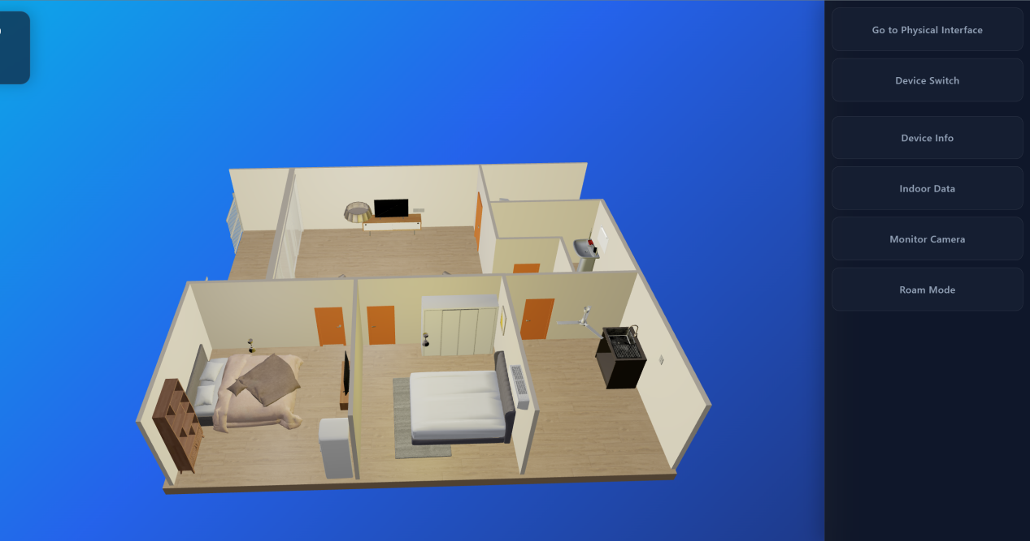
Figure 1: Digital Twin Main Interface (Twin Overview + Right Navigation)
Core layout: The left side features a 3D room scene as the primary action zone, while the right side displays a fixed vertical menu as the function navigation zone. This design decouples navigation from 3D interactions, preventing users from having to search for entry points within the model.
Navigation logic: The right-side button (Go to Physical / Device Switch / Device Info / Indoor Data / Monitor / Roam) is a primary function. Clicking it activates the corresponding mode or panel.
Interactive features: Users primarily rotate/observe through the 3D window using the mouse, and switch tasks (control, view, monitor, roam) via the right-side menu, reducing learning costs.

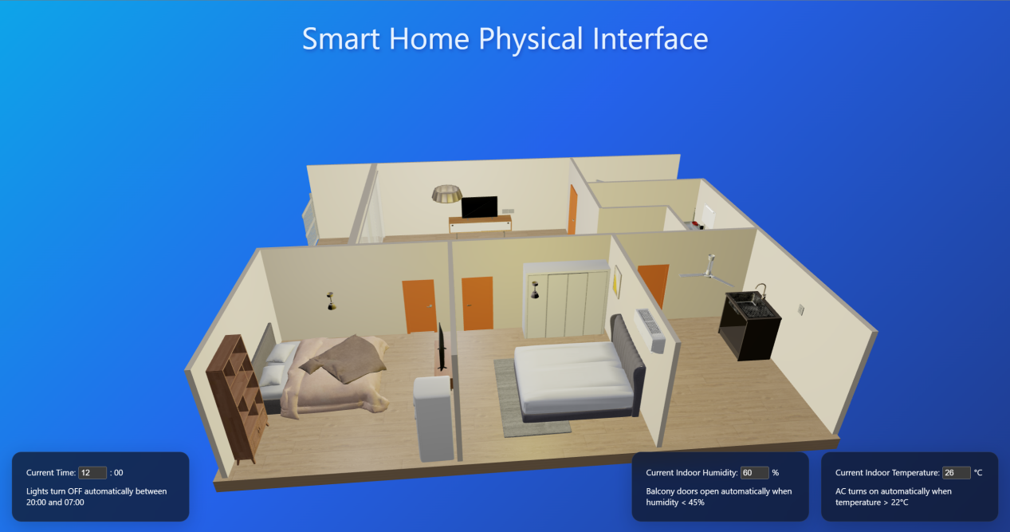
Figure 2: Physical Interface (Sensor Input + Automatic Rule Prompt)
Core Objective: Use physical input to drive twin-end state changes. The interface highlights input values and automation rules in the bottom card.

Input interaction: Time, humidity, and temperature use intuitive input controls (shown as numeric inputs/selections in your diagram). When users modify these settings, the system should immediately recognize the change as a sensor reading update and trigger the rule accordingly.
Rule Interpretability: Each card displays the current value and explains the rule in one sentence (e.g., 'Turn on AC if temperature exceeds 22°C, open balcony door if humidity drops below 45%, turn off lights at night'). This is a classic Explainable UI design that helps users understand why the device automatically adjusts.

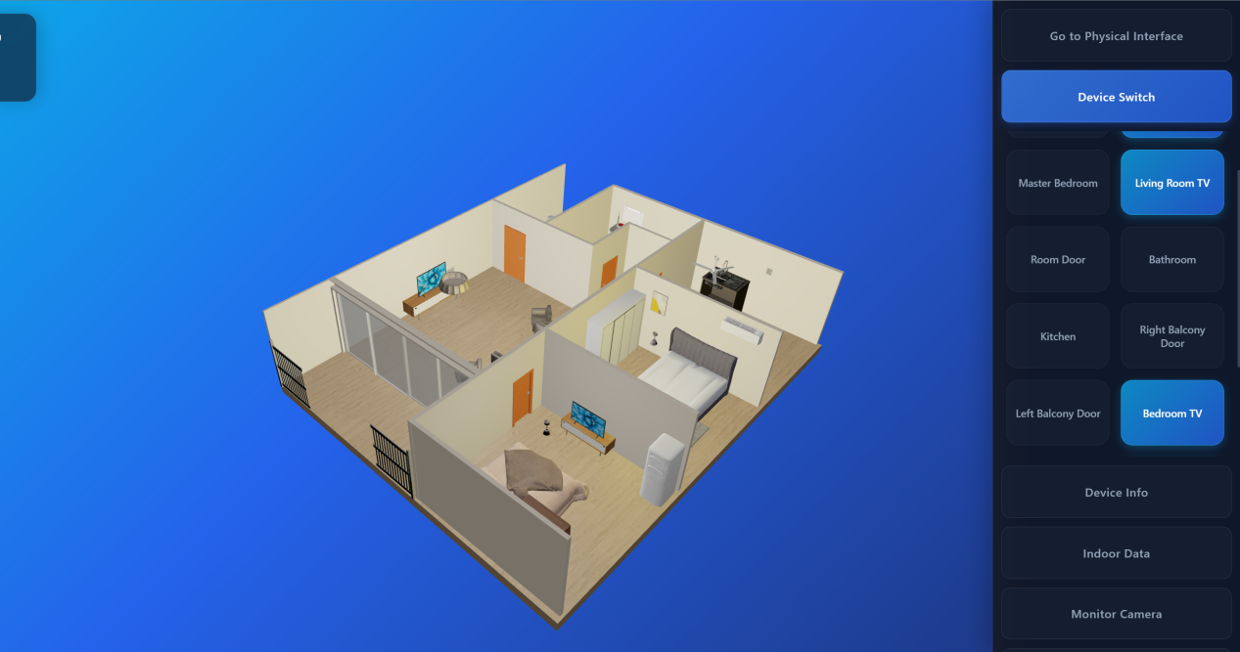
Figure 3: Device Control Interface (Device Switch: Device List/Button Matrix)
Interaction method: The device uses a button matrix display. Clicking a button allows you to toggle the switch, which is classified as 'direct manipulation'.
Status feedback: The selected device button displays a brighter blue highlight (e.g., Living Room TV/Bedroom TV) to provide real-time feedback on the current operation target and status.
Advantages: More stable and efficient than selecting points individually in 3D models; while retaining the 3D window for observing effects (lights on, doors open, TV on, etc.).

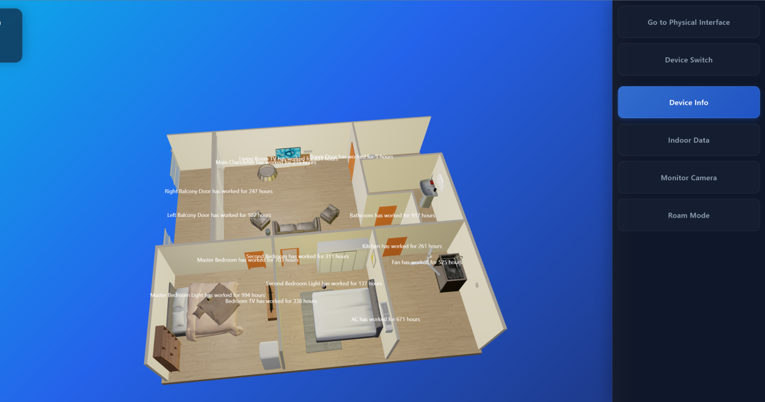
Figure 4: Device Info interface (3D scene overlay)
Information presentation strategy: Without altering the scene structure, overlay labels are displayed on corresponding spatial positions for each device's text information, similar to AR annotations.
Readability Design: Users can still turn off or toggle features from the right side at any time, avoiding being left with no options when information is obscured. When labels are densely packed, users can rotate the view to find the target area.
Scenarios: For "Status Inspection/Overview" (e.g., cumulative working hours, equipment operation alerts), this method is faster than clicking through individual items.

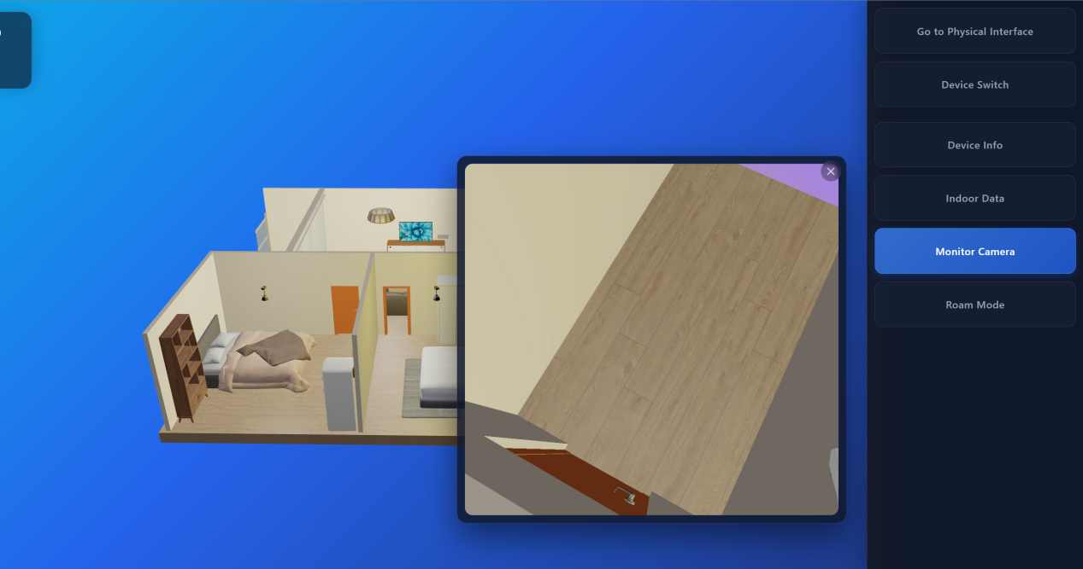
Figure 5: Monitor Camera (a pop-up window that can be closed)
Interaction mode: The monitoring interface uses Modal/Popup windows, overlaying the main view without forcing page navigation to maintain contextual continuity.
Clear close mechanism: The 'X' in the top-right corner is an explicit close button, aligning with users' expectations for video pop-ups.
Design Objective: Present 'monitoring' as a call-out tool rather than a standalone page that interrupts the main task, demonstrating the 'twin-end integrated monitoring capability'.

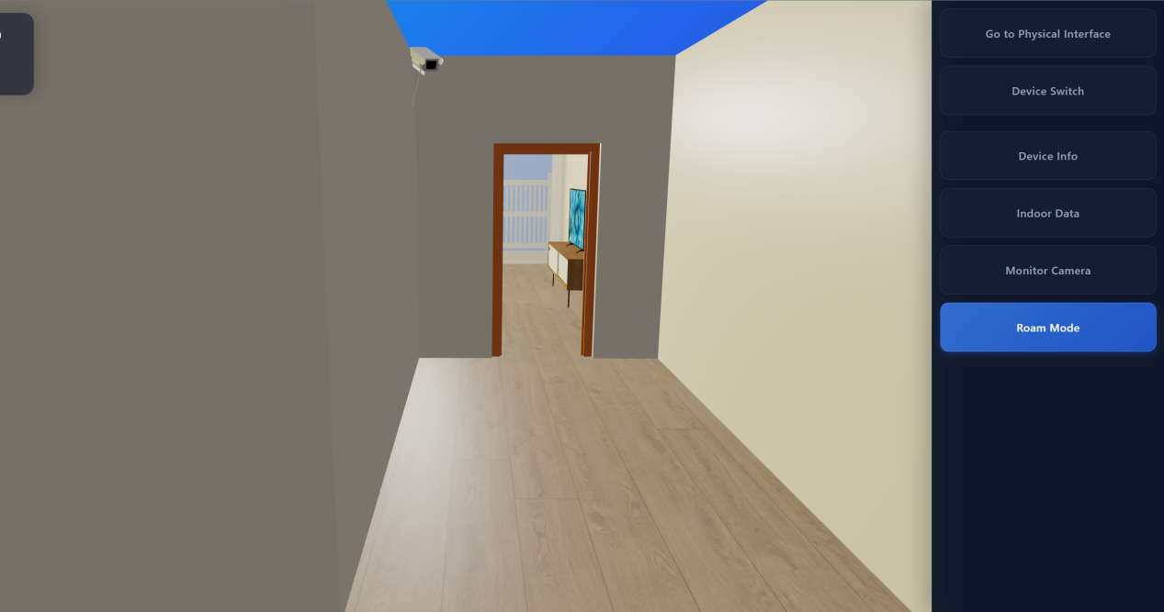
Figure 6: Roaming Mode (First-person/Indoor Walking)
Clear mode switching: The right-side Roam Mode highlight indicates the current 'Roaming Mode' status. This is a classic example of 'mode-based interaction' requiring clear status cues – and you've nailed it.
Interaction mode evolution: The system transitions from top-down observation/rotated scenes to immersive indoor navigation with near-first-person perspective (typically controlled via WASD/mouse), delivering an immersive inspection experience.
Optimization focus: The roaming system prioritizes spatial awareness, employing collision/boundary detection to prevent mode-jumping (a feature already implemented in the project), making movement feel like real indoor navigation.

4.4 Complete list of project features

Module/Page  （ route ） | Feature | Description (What you implemented) | Interaction Method/Effect
User System (/ Home) | Sign in / Sign up | Enter username and password. If the user does not exist, the system will create user data (including device initial status, temperature and humidity, time, etc.) and log in. If the user exists, the system will verify the password to log in. | After successful login, write to localStorage.user and jump to /twin
User system (/twin) | Account Information & Sign Out | Displays the current user name. Clears localStorage.user and returns to the home page when exiting. | Click Logout in the Account panel
User Management (Control Panel Pop-up) | User list, change password, and delete user | IndexedDB user table: Supports Update (save changes) and Delete | Click User Management on the Control Panel to open the management interface
Digital Twin Home (/twin) | 3D room digital twin scene loading | Load public/models/HOUSE/house.gltf to build interactive indoor scenes | Render the 3D room model after entering
Digital twin | Device Switch Control | The control panel lists the following devices: air conditioner, TV, door, kitchen/bathroom, balcony doors, fan, and room lights (14 categories in total). | Click the panel device name to switch the device status (on/off) and drive model animation/material changes
Digital twin | Device Info | Attach a CSS2D tag to the device to display "This device has been working for X hours" (from the duration in user data) | Click Device Info on the Control Panel; also supports "Click an object to show information" interaction
Digital twin | Scene click/double-click interaction | Click: Shows information; Double-click: Switches on/off (by picking up the mesh with rays) | Interact with devices/components in the mouse point model
Digital twin | Roam Mode + Collision Limit | When roaming is enabled, use W/A/S/D to move based on camera orientation. Raycaster collision detection is applied to objects ahead to prevent "crossing the model". | Tap Roam Mode on the Control Panel to experience indoor navigation in first-person perspective
Digital twin | Monitor Camera | Play local monitoring video in pop-up window public/video/JianKong.mov | Click Monitor Camera on the Control Panel to open a drag-and-drop video window
Data Panel (Control Panel pop-up) | Indoor Data Visualization | Use ECharts to provide four types of charts: Temperature, Air Quality, Power Consumption, and Water Consumption. | Click Indoor Data on the Control Panel to open the drag-and-drop data panel or chart
Physics interface (/physics) | The physical end sensor inputs analog signals. | Provide slider adjustments for temperature (°C), humidity (%), and time (hour), and write to IndexedDB | Update data and trigger twin-side linkage immediately after adjusting the slider
physical end ↔ twin end linkage | Automation rules (intelligent control logic) | Rules are written in SwitchController.asyncDevice (): temperature> 22 automatically open the air conditioner; humidity <45 automatically open the balcony door; 20:00-07:00 automatically turn off the light (daytime light on) | After changing temperature, humidity, and time in /physics/, the twin device will automatically switch to the rule-compliant state.
3D interactive presentation (/move) | A Simplified Example of 3D Scene Roaming | Use the ThreeHelper + OrbitControls + Sky environment; keyboard controls movement | For basic 3D interaction/roaming capabilities (more for demo)
Data persistence (global) | IndexedDB + localStorage | IndexedDB (smart_house) saves user and device status/sensor data; localStorage.user saves current login status | User data and device status can still be restored after refreshing the page

4.5 Project Operation Manual
After the system launches, users first access the homepage login/registration interface (/). Entering the username and password completes identity verification: For first-time users, the system automatically creates initial data (including default values for device status, indoor temperature/humidity, and time) and logs in directly. For existing users, the system verifies the password and redirects to the digital twin main interface (/twin). Login status is saved locally in the browser to maintain session continuity after page refresh. To log out, users can click "Logout" in the account area of the twin terminal to clear local login information and return to the homepage.
Upon entering the digital twin main interface (/twin), the central area displays the 3D house model's main view, with a fixed function control panel on the right. Users can observe the house structure and room layouts through mouse interactions in the main view, while the right-side buttons switch between various modes: Device Switch, Device Info, Indoor Data, Monitor Camera, Roam Mode, and Go to Physical Interface. This "3D main view + side function bar" design separates observation/interaction from function access, ensuring clear operation paths. Users can complete core tasks without searching for buttons within the model.
In the "Device Switch" interface, the system displays controllable devices (e.g., air conditioners, doors, kitchen/bathroom units, balcony doors, TVs, fans, and room lights) as a button array. Users can toggle devices by clicking buttons, with the interface highlighting selected or active devices. Simultaneously, 3D scenes dynamically reflect these changes—lighting variations, door movements, and status updates for fans or TVs. This design prioritizes "panel quick control," allowing real-time verification of control effects in 3D views, thus creating a seamless "operation-feedback" loop.
In Device Info mode, the system overlays text labels on devices within 3D scenes to display status information (e.g., cumulative runtime). This mode is ideal for inspection and overview: users can view device operation data across the entire building space without manual selection. When labels are numerous, users can adjust the view to focus on specific room areas. The right-side panel allows instant mode switching to minimize obstructions, ensuring optimal balance between information display and scene observation.
"Indoor Data" facilitates real-time monitoring and visualization. Clicking it displays a data panel with statistical charts for temperature, air quality, electricity, and water usage, helping users progress from device-level insights to operational metrics. The panel supports drag-and-drop functionality without interrupting 3D scene operations. Meanwhile, "Monitor Camera" plays surveillance footage in a pop-up window. Users can open/close the camera view without page navigation, enabling instant access to simulated camera angles and achieving dual viewing of "twin-end scenarios + monitoring perspectives".
When users activate "Roam Mode," the interaction shifts from top-down observation to a more immersive indoor navigation experience. Typically, they can move around using the keyboard (e.g., WASD) and adjust their perspective with the mouse to explore the interior of a building. The system incorporates basic collision and boundary restrictions to minimize camera mode penetration, enhancing realism and usability. This mode is particularly effective for demonstrating the spatial value of digital twins, such as entering a room from a corridor or examining device proximity relationships.
The system also provides a "Physical Interface (/physics)" to simulate real sensor inputs. Users modify environmental data through controls like time, temperature, and humidity via the physical interface. The system writes local data to the data layer, triggers automation rules, and synchronizes with the twin device status. For example: automatic air conditioning activation when temperature exceeds thresholds; balcony door opening when humidity drops below thresholds; nighttime light deactivation. The recommended demonstration process involves: first adjusting values in /physics, then checking /twin to observe rule-based device actions, thereby demonstrating the closed-loop process of "physical input → data synchronization → rule decision → twin execution". For user management, the twin device's "User Management" provides features like user lists, password modification, and account deletion. To reset historical status, users can delete corresponding data in localStorage and IndexedDB through the browser.

V. Team and Project Management

5.1 Team Members and Their Responsibilities
This project was collaboratively developed by Zhang Honghao, Jiang Lei, Ren Tianyang, and Lan Kun. The team adopted a layered development approach: "foundation layer (engineering and data) → 3D scene interaction → device control linkage → business panel and user management." Jiang Lei handled engineering initialization and local data persistence infrastructure. Ren Tianyang managed core 3D twin scene capabilities and critical interaction chains including device recognition, animation, and audio. Lan Kun oversaw the account system, device status switching, and statistical analysis. Zhang Honghao was responsible for 3D visual effects (lighting and rendering optimization), model and texture assets, as well as the visualization of monitoring and analysis panels and the preparation and integration of team reports.
Zhang Honghao (Report Writer / Head of Visual and Performance): Developed 3D models and texture mapping for the building and related equipment, ensuring asset quality and display consistency. Implemented and optimized lighting systems and rendering loops on the twin platform to enhance visual presentation and interaction fluidity. Participated in designing and implementing the visual presentation for monitoring and analysis panels. Organized the structure and content of team reports, ensuring all members' contributions were systematically presented and aligned with system requirements.
Jiang Lei (Head of Engineering and Data Infrastructure): Responsible for project initialization (including system setup, GitHub repository creation, and basic configuration), and leads the implementation of local persistence layers (Local Data Storage, State Persistence, Data Synchronization). This ensures stable storage and synchronization of user data, device status, and sensor data on the browser side, providing a reliable data foundation for twin-end integration, monitoring analysis, and user system operations.
Ren Tianyang (Head of 3D Interaction and Device Linkage): Responsible for the core 3D capabilities of the twin end, including Three.js/WebGL scene initialization, camera control, user interaction detection, roaming control, etc.; completing key links such as automatic device registration and recognition, GLTF animation management, 3D spatial audio in device linkage, and implementing status monitoring and device list display in the monitoring module; while also completing the creation of Azure projects to support project collaboration and deployment management.
Lan Kun (Business Function and Analytics Lead): Responsible for implementing business-side system functionalities, including login/registration and super administrator management. In the device module, he manages device status switching and persistence to ensure user actions are accurately reflected in system status. In the monitoring and analysis module, he conducts statistical analysis, transforming device/environmental data into actionable insights for presentation and decision.

5.2 Project Task Breakdown and Time Planning
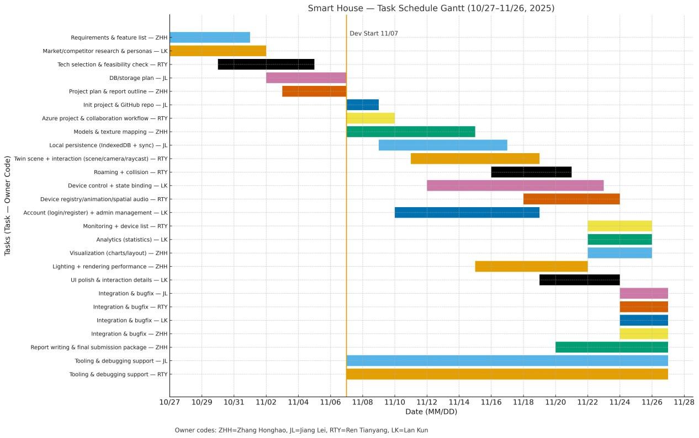
Figure 5.1 Project Gantt Chart

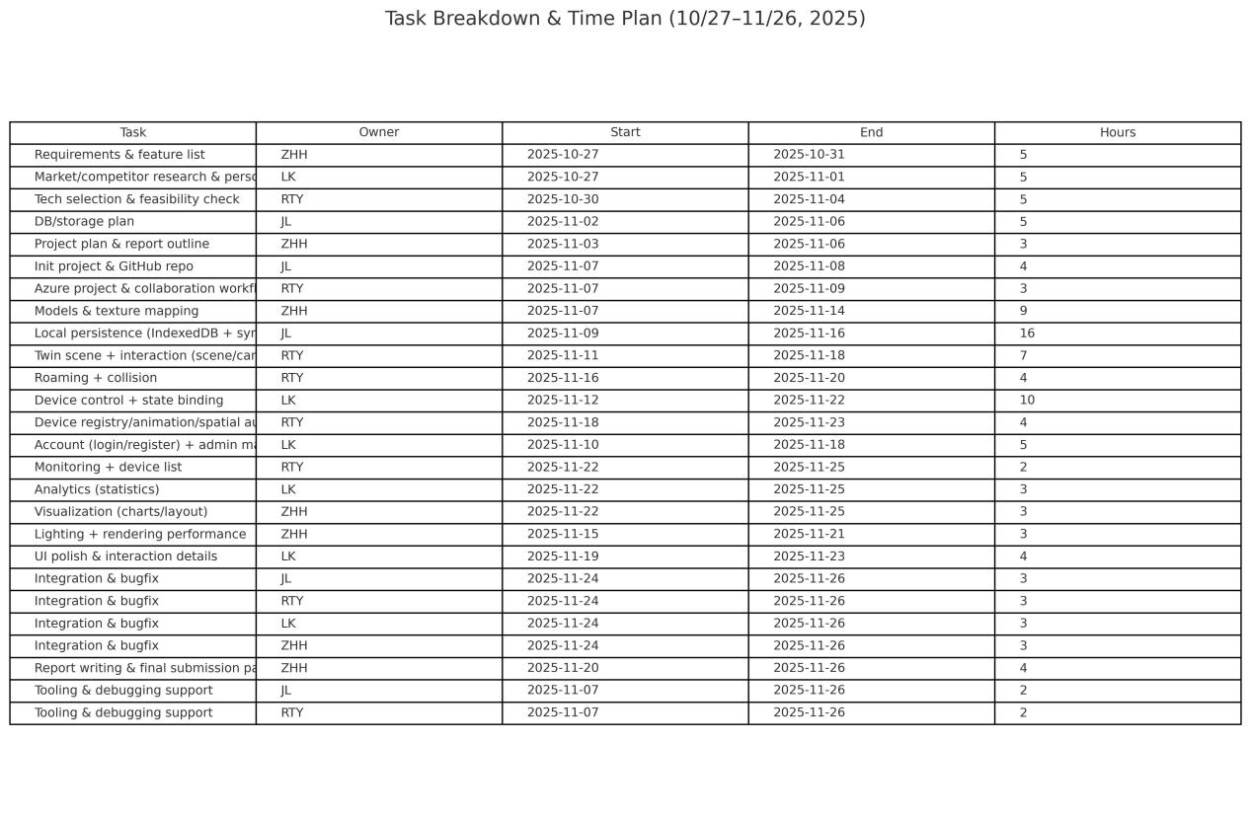
Figure 5.2 Task Details List
Total investment: 120 person-hours (≥100)
Input per capita: 30 person-hours/person (≥25)
Owner Code: ZHH (Zhang Honghao), JL (Jiang Lei), RTY (Ren Tianyang), LK (Lan Kun)

5.3 Communication and Management Mechanisms
Hold weekly Teams online meetings and offline library meetings for weekly review and communication. Simultaneously, use WeChat for real-time communication.

VI. Risk Assessment and Countermeasures

6.1 Technical Risks
Fragmentation in protocols and device ecosystems (Wi-Fi/BLE/Zigbee/MQTT/Matter/private protocols) may lead to high driver adaptation costs. Browser-based digital twins impose performance thresholds on modeling and rendering, potentially causing frame drops on low-end devices. Real-time control and state consistency (UI/data/device) often fail to align in offline or weak-network scenarios. Surveillance videos face challenges with codec issues, cross-domain compatibility, and latency. Security vulnerabilities—such as weak passwords, insufficient permissions, and lack of local encryption—pose risks of data theft or breaches. Compatibility issues across browsers and devices (e.g., Safari on mobile devices, hardware decoding differences) may also degrade user experience.

6.2 Market Risks
Users have a learning curve for 3D spatial interfaces and the "one-stop platform," and may prefer existing voice/manufacturer apps in the short term. Leading ecosystems (Apple/Google/Amazon, Xiaomi/Huawei/Tuya) iterate quickly and have strong binding. If similar low-cost solutions are introduced, they will compress our differentiated space in "low modification, visualization, and offline availability." While the trend is toward enhanced privacy and local priority awareness, users' perception of actual energy-saving benefits and willingness to pay remain uncertain. Hardware price fluctuations and supply chain instability may also affect installation willingness and the energy-saving return cycle.

6.3 Managing Risks
Within a tight schedule, parallel execution of visualization, device adaptation, data layer, and security baseline may result in integration delays and quality fluctuations. Expanding requirements and frequent version changes can disrupt timelines. Critical team members taking leave or scheduling conflicts may reduce delivery capacity (Bus Factor). Insufficient test coverage and weak regression processes could expose latent defects near the presentation. External dependencies (e.g., open-source library updates or browser policy changes) may also cause temporary bottlenecks.

6.4 Response Strategies
The "Device Capability Model + Adapter Pattern" isolates protocol differences, prioritizing coverage for Class 5+ high-frequency devices while retaining MQTT/Matter gateway interfaces. Performance budgeting (DRACO compression, LOD, cone clipping, on-demand rendering) and hardware baselines are established, providing fallback to 2D panels for low-spec configurations. A "Optimistic Updates + Periodic Reconciliation" shadow mechanism ensures consistency, prioritizing offline updates with post-launch compensation synchronization. Video processing prioritizes local short links, degrading to snapshot polling if failed. Security implementations include strong passwords, least privilege, token rotation, and local encryption. Management adopts milestone-based MVP scope locking, MoSCoW prioritization, and daily stand-up meetings. CI/CD mandates lint checks, unit testing, and end-to-end regression, setting ≥70% coverage with feature toggles for phased scaling. Cross-team reviews and Code Owners reduce Bus Factor, with pre-configured buffers and contingency plans (replacing libraries/backup hardware/demonstration scripts). Market validation through prototype usability testing and energy efficiency comparisons establishes replicable ROI cases to address competitive uncertainties and user acceptance.

VII. CONCLUSION AND FUTURE PROSPECTS

7.1 Project Summary:
This project addresses issues such as "fragmented multi-brand control, asynchronous states, offline inavailability, and invisible energy consumption" in smart homes by completing a 3D digital twin prototype system that can run on browsers. The system uses Next.js/React/TypeScript to build an interactive framework, Three.js to achieve 3D visualization and interaction in home spaces, and IndexedDB to provide local-first data persistence. It ensures consistency between UI/data/scenarios through a device state machine and reconciliation mechanism, supporting major controls and status displays even in offline or weak network scenarios. Functionally, the project implements account login/registration and user management, 3D scene loading and roaming, device switching with animation/material/lighting synchronization, device information tag overview, monitoring window pop-ups, indoor data chart panels, and a closed-loop demonstration of "physical input → rule triggering → automatic linkage on the twin side," covering typical equipment and scenario needs such as lighting, doors/windows, air conditioners, TVs, and cameras. Overall, the team completed the end-to-end closed loop from research and selection to joint debugging within a limited timeframe, laying an extensible system framework and interaction paradigm for subsequent integration with real gateways, standard protocols, and energy efficiency evaluations.

7.2 Next steps:
Future iterations will advance through four core dimensions: authentic device integration, enhanced policy frameworks, robust reliability and security, and refined user experience. First, in device connectivity, we will address gateway layer integration and protocol compatibility, prioritizing implementation of MQTT/WebSocket/REST authentic links while progressively expanding to standard ecosystems like Matter/Thread, establishing reusable device adapters and capability models. On automation, we will introduce comprehensive scenario orchestration (configurable conditional/timing/trigger rules) and alert notification mechanisms (door sensors/intrusion detection/waterlogging), transitioning energy consumption statistics from "demonstration data" to "real-time measurement + time-based aggregation" for credible ROI evaluation. Regarding reliability and engineering quality, we will implement systematic testing (unit/integration/E2E), exception fallback strategies (network disconnection/data corruption/device unavailability), and log/metric collection to improve stability and maintainability. For security and availability, we will strengthen RBAC (Role-Based Access Control) authentication, local encryption of sensitive data, and operation auditing, while optimizing mobile compatibility, accessibility, and performance (fine-grained on-demand rendering, LOD/cropping strategies) to enable the prototype to demonstrate deployable and demonstrable capabilities closer to real-world products.

VIII. References and Appendices
Next.js Docs: https://nextjs.org/docs
React Docs: https://react.dev/
Three.js Docs: https://threejs.org/docs/
ECharts Docs: https://echarts.apache.org/
MDN IndexedDB: https://developer.mozilla.org/en-US/docs/Web/API/IndexedDB_API
MDN WebGL: https://developer.mozilla.org/en-US/docs/Web/API/WebGL_API
glTF 2.0 Spec: https://registry.khronos.org/glTF/specs/2.0/glTF-2.0.html
Matter (CSA): https://csa-iot.org/all-solutions/matter/
Digital Twin survey (Fuller et al.): https://arxiv.org/pdf/1911.01276
Smart Home Digital Twin (Sensors 2023): https://www.mdpi.com/1424-8220/23/17/7586

